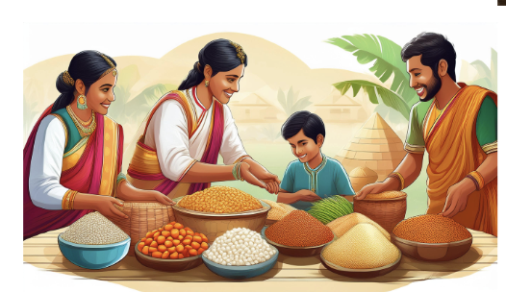

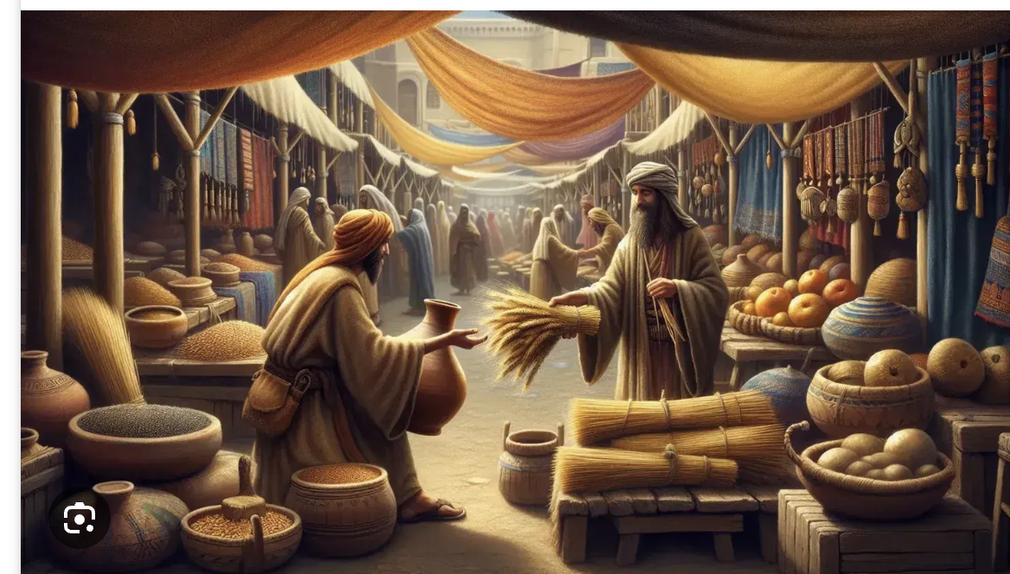

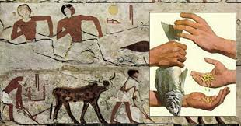

• Barter means trading things without money.

• You give something you have.

• You get something you want.

• If you have apples, and your friend wants apples, you can trade.

• If your friend has a toy, and you want the toy, you can trade.

• You must both want what the other has.

• It's like swapping toys with a friend.

• Sometimes, it's hard to know how many apples a toy is worth.

• Long ago, people used barter.

• Some people still trade things without money today.

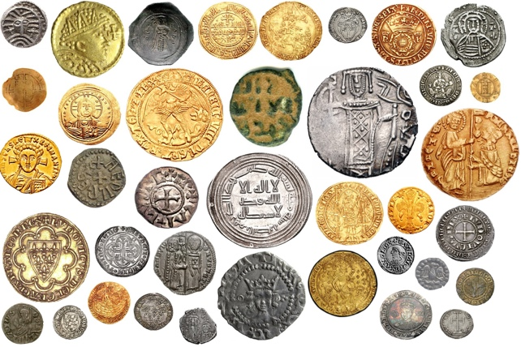

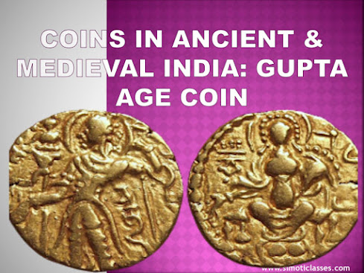

• Long ago, people used shiny coins like we use money today.

• Kings and queens made the coins.

• Each coin had a special picture on it.

• People used coins to buy food and toys.

• Big coins could buy big things, like a horse.

• Small coins could buy small things, like bread.

• Merchants kept coins in bags.

• Sometimes, people hid coins in pots.

• Coins helped people trade easily.

• Coins were made of gold, silver, or copper.

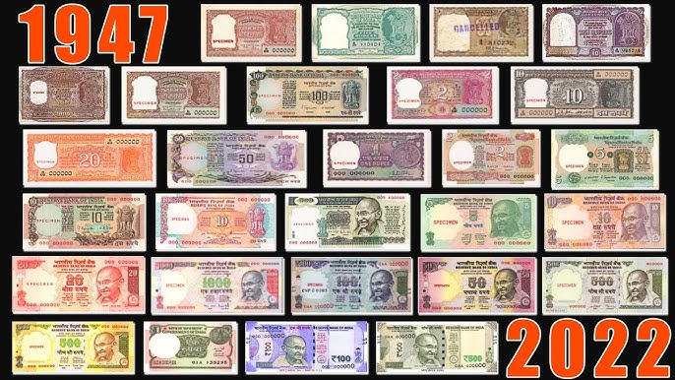

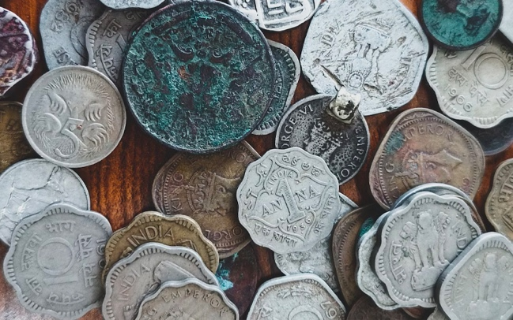

• After India became free, we still used coins and paper money called rupees.

• The RBI (like a big bank for India) made them.

• Coins were round and shiny, made of metal.

• Rupee notes were paper, with pictures of leaders.

• Small coins could buy candies and small toys.

• Big rupee notes could buy food and clothes.

• People kept coins in little purses.

• They kept rupee notes in their pockets or wallets.

• Coins and rupees helped us buy things at shops.

• They helped us trade easily, just like money today!



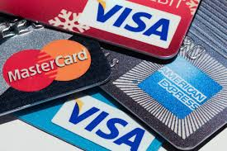

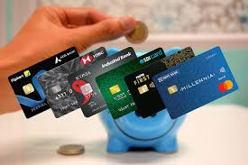

• Long, long ago, people traded things, like apples for toys.

• Then, shiny coins came along, made of metal.

• Later, paper money, like rupee notes, was used.

• Grown-ups found carrying lots of coins and paper notes hard.

• So, they made cards that hold money in a secret place, like a bank!

• Debit cards take money right away from that secret place.

• Credit cards let you buy things now, and pay later.

• Computers and phones came along, and money became digital.

• GPay is a phone app that uses digital money to pay.

• Now, grown-ups can tap their phones to buy things, like magic!